**MEL G641 CAD for IC Design**

**Project Report**

**GUI implementation of CAD algorithms using Python**

Ganesh Prasad B K (2018H1230151G)

M.E Microelectronics

Department of Electrical & Electronics

BITS Pilani – K K Birla Goa Campus

Zuarinagar, Goa 403726

Below are the output images of GUI implemented for various algorithms on CAD

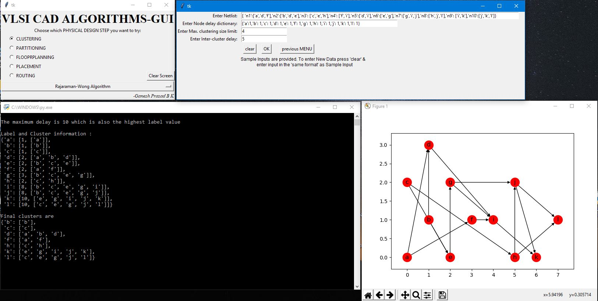

**Clustering: Rajaraman-Wong Algorithm**

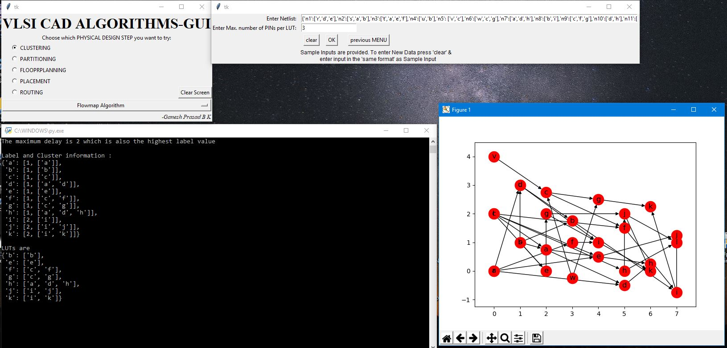

**Clustering: Flowmap Algorithm**

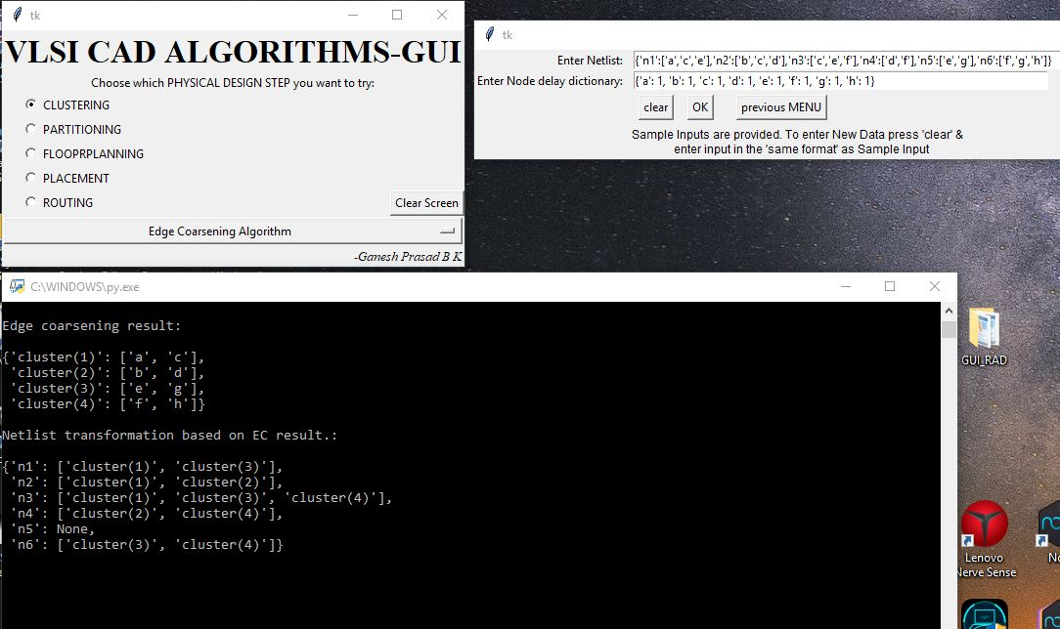

**Clustering: Edge Coarsening Algorithm**

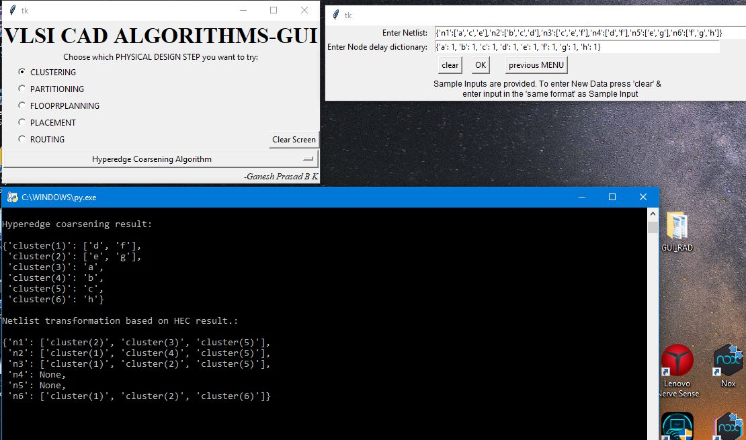

**Clustering: Hyper-Edge Coarsening Algorithm**

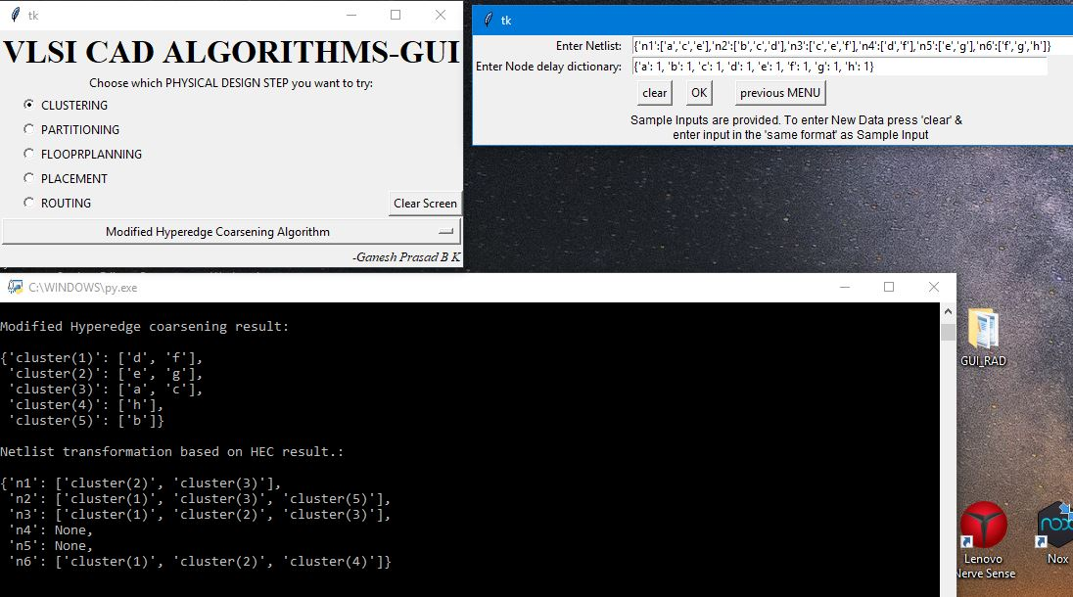

**Clustering: Modified Hyper-Edge Coarsening Algorithm**

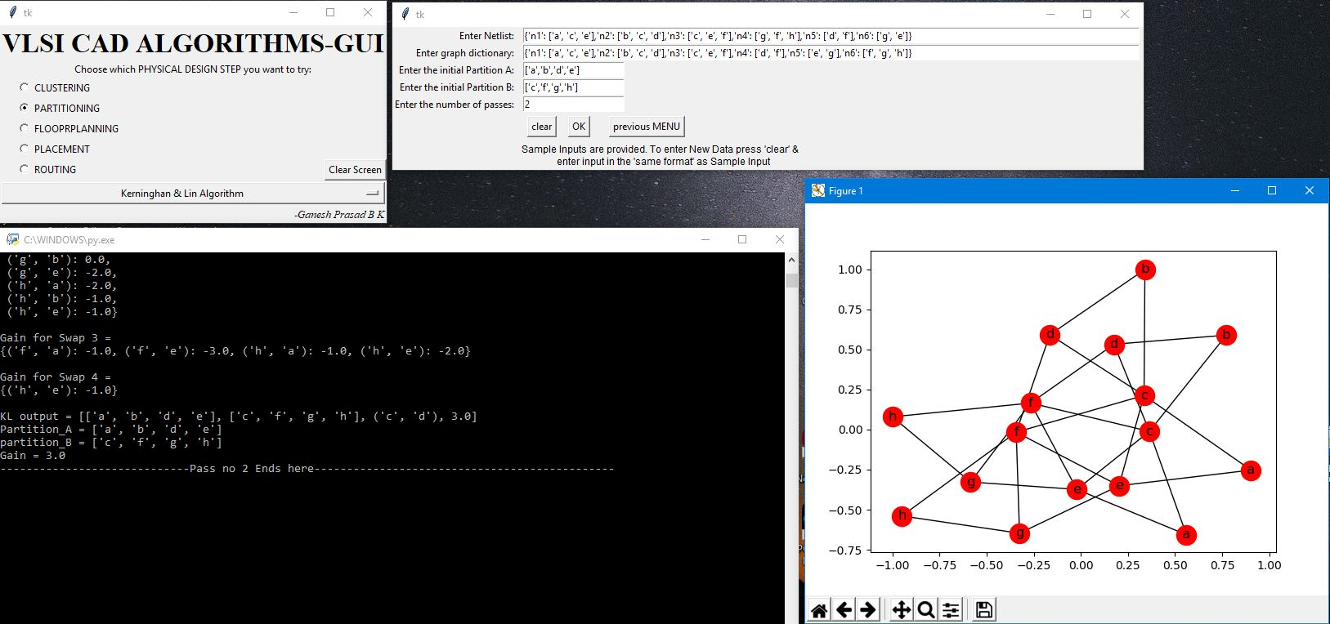

**Partitioning: Kernighan-Lin Algorithm**

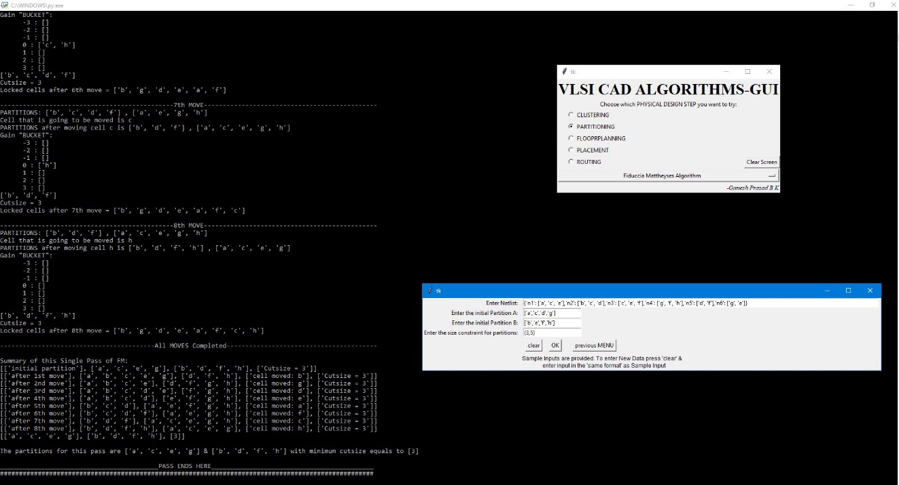

**Partitioning: Fiduccia-Mattheyses algorithm**

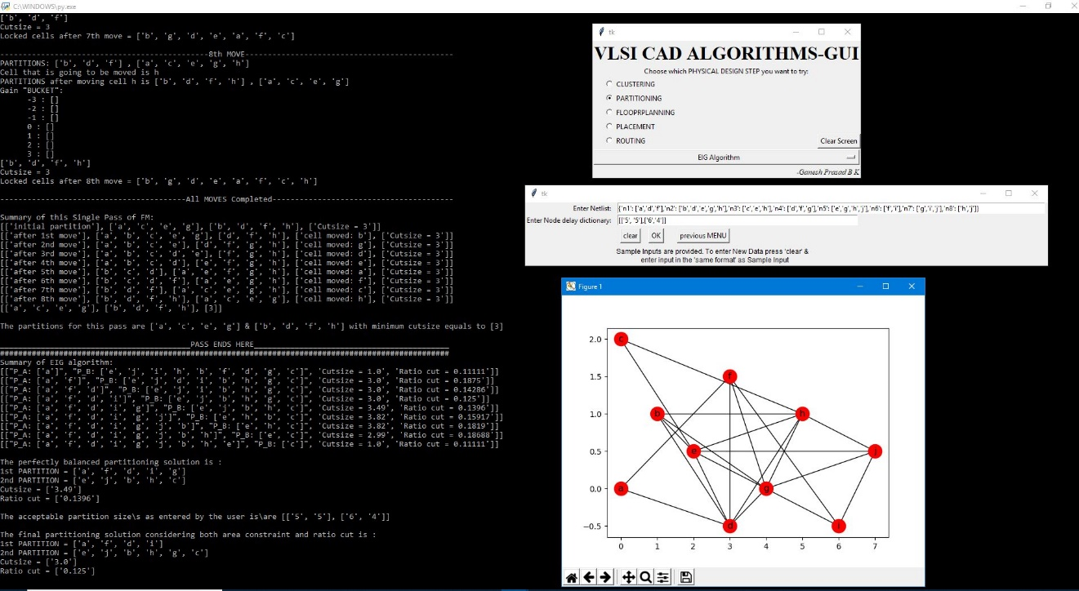

**Partitioning: EIG Algorithm**

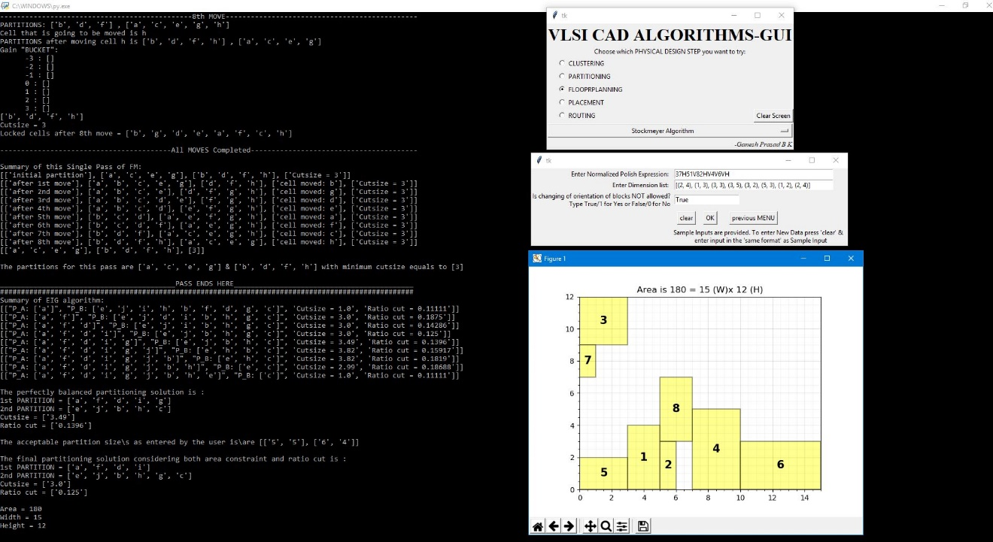

**Floor planning: Stockmeyer Algorithm**

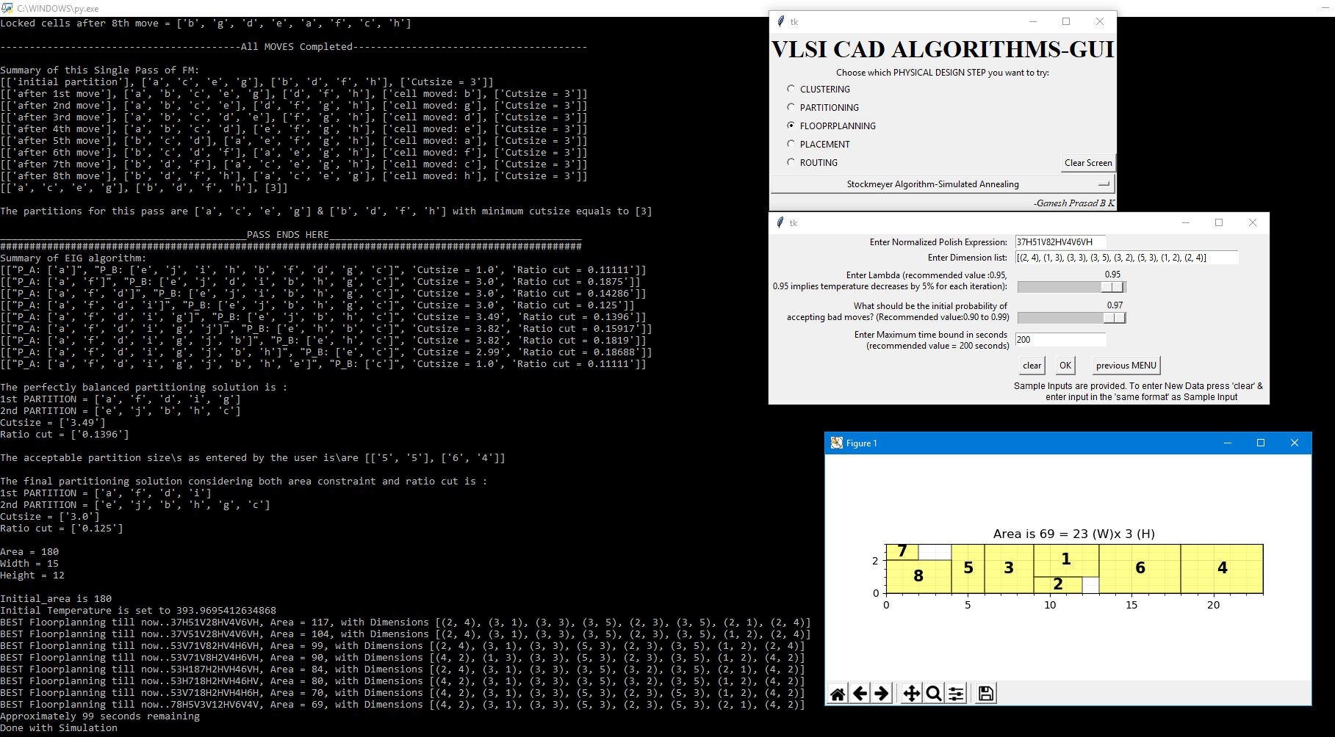

**Floor planning: Stockmeyer Algorithm with Simulated annealing**

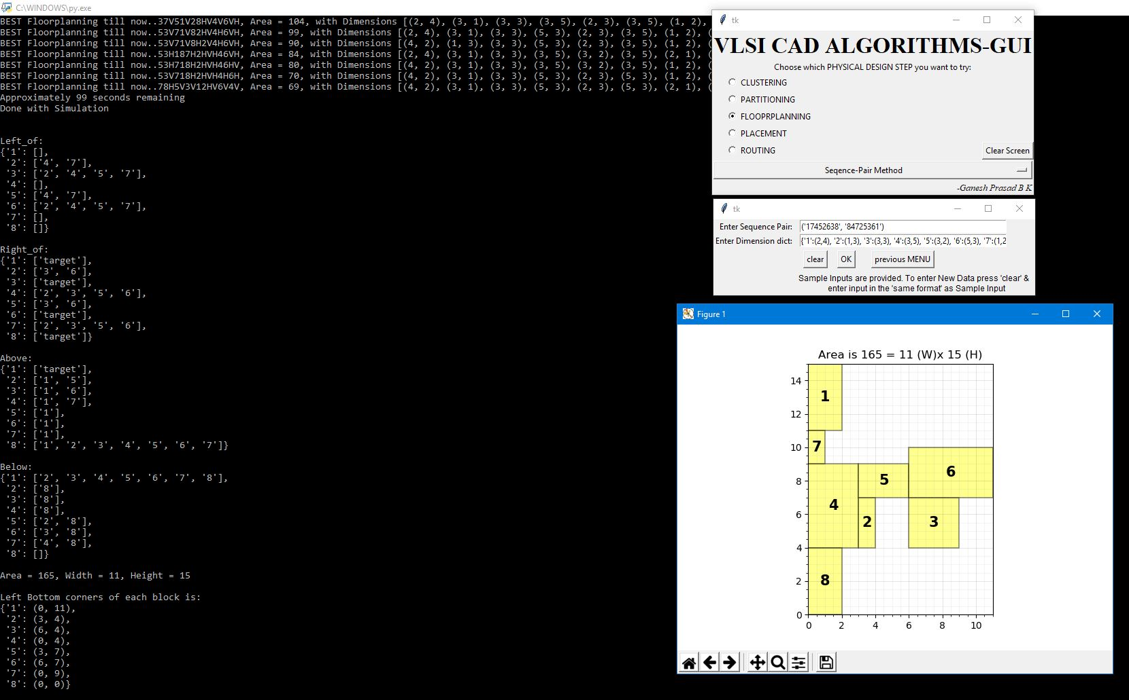

**Floor planning: Sequence-Pair Method**

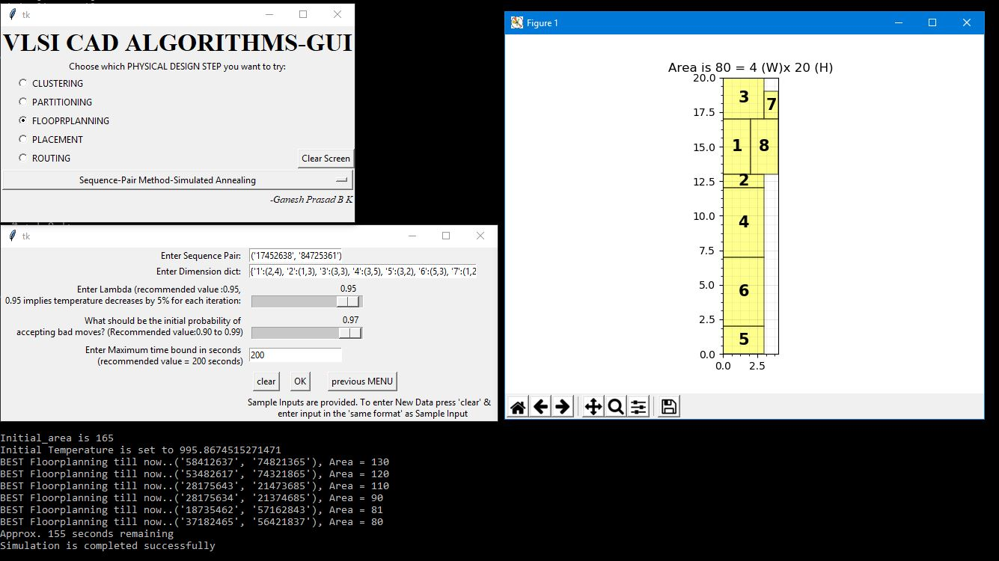

**Floor planning: Sequence-Pair Method with Simulated annealing**

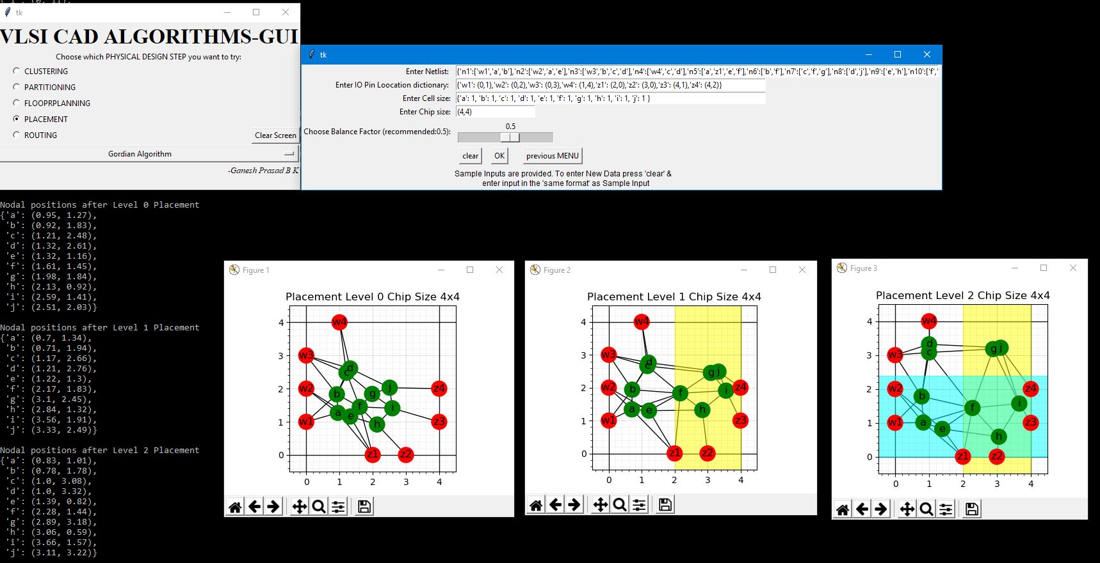

**Placement: Gordian Algorithm**

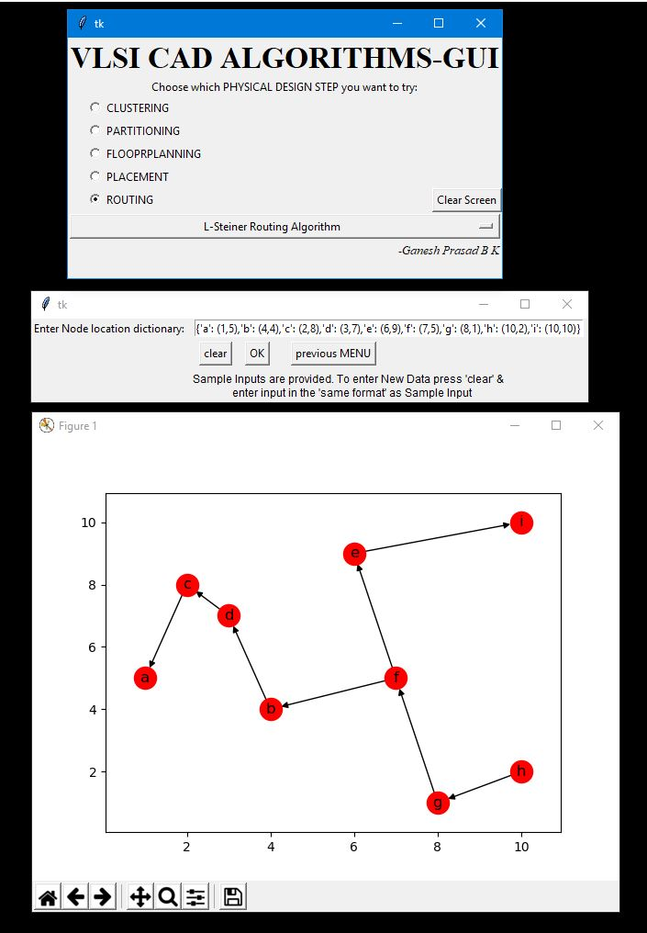

**Routing: Steiner Routing Algorithm**